Program Specification Manual

This document describes the main program logic. Additionally, the detailed logic is written in the code comments.

1. System Architecture & Core Logic Overview
This system (DocuGIS2 / MUNDa) is a browser-based Single Page Application (SPA) designed to transform unstructured or semi-structured text data (specifically DocuXML) into spatio-temporal visualizations.
The architecture follows the Separation of Concerns principle, dividing the system into three primary layers: the View/Skeleton, the Business Controller, and the Spatial Model.
- Data Flow Pipeline: The system utilizes a "Read → Parse → Normalize → Render" linear data flow:
  - Input Layer: Managed by n.js, which listens for and reads user-uploaded files (DocuXML/JSON/TSV).
  - Processing Layer: Raw text is parsed and passed to the DocuGIS class in m.js for instantiation. At this stage, temporal (Date) and spatial (Lat/Lng) data are normalized and validated.
  - Presentation Layer: The normalized data is dispatched synchronously to three visualization modules: the Map View (m.js), the Data Grid (n.js), and the Time Slider (n.js).
- Module Orchestration:
  - index.html: Serves as the system container, defining the DOM structure and loading dependencies (Leaflet, jQuery, etc.).
  - n.js (General Controller): Acts as the system's "Brain." It handles DOM event binding (e.g., button clicks, file uploads), UI state management (e.g., sidebar toggling), and coordinates the interaction between the data grid and the map.
  - m.js (Map Model & View): Acts as the "Map Engine." It encapsulates all Leaflet-related GIS operations, maintains the DocuGIS data model, and generates GeoJSON layers.
This architecture ensures the decoupling of general UI logic from complex map logic, allowing for scalable GIS enhancements (e.g., adding layers, changing projections) without disrupting basic file processing functions. Based on the analysis of index.html, n.js, and m.js, here is the system documentation and process flowchart.
This system (MUNDa) is a Web-based Geographic Information System designed to transform text data (specifically DocuXML) into Spatio-Temporal Maps.
Here are the two required deliverables:
- DocuXML to Map & Analysis Process Flowchart
- Code Documentation (Tree Structure)

1. System Process Flowchart (DocuXML Upload -> Map -> Analysis)
This flowchart illustrates the internal logic flow from the moment a user uploads a file to the system rendering the map and enabling analysis tools.
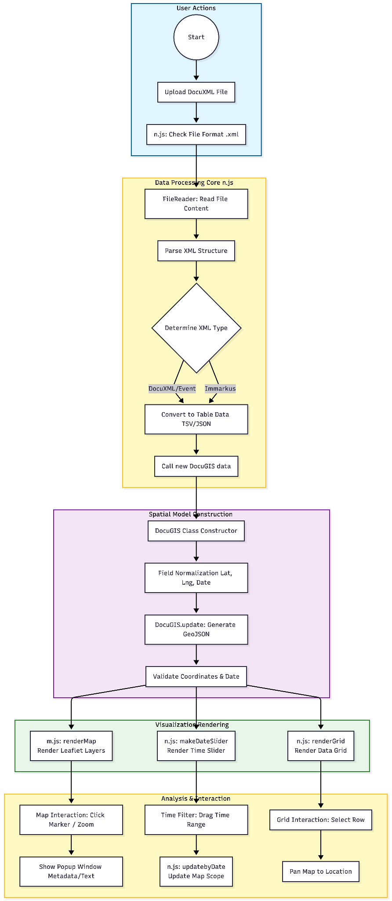

2. Code Documentation (Tree Structure)
The following breaks down the functionality modules of the three files into a tree structure for your documentation.

📂 DocuGIS2 / MUNDa System Architecture
- 📄 index.html (System Entry & UI Skeleton)
  - Overview: Defines the DOM structure, imports necessary CSS/JS libraries (Leaflet, jQuery, jqGrid), and configures the main UI blocks.
  - Key Sections:
    - head: Imports dependencies like Leaflet, jQuery, jqGrid, and GIS plugins (MarkerCluster, Heatmap, etc.).
    - body:
      - .sidebar.left (Left Sidebar):
        - Menu: Import Data, Search, Time Range, Export, Settings.
        - Branding: Logo and Language Switch (.language.switch).
      - .sidebar.bottom (Bottom/Functional Panel):
        - #tabs: Containers for User Guide, Import Interface (#fileUpload), Search Panel, and Time Slider Container (#slider).
      - .content (Map Container):
        - #map: The main mounting point for the Leaflet map.
      - #jqGrid: Area for displaying data tables.
- 📄 n.js (Controller Logic & Data Processing)
  - Overview: Handles non-map business logic, including file reading, data conversion, UI interaction control, and backend/AI integration.
  - Core Modules:
    - File Import Handler
      - $('#fileUpload').change & $('#uploadFile').click: Listens for file uploads.
      - Format Detection: Distinguishes between .tsv, .csv, .json, .xml.
      - XML Processing: Parses DocuXML/Event XML and calls converters to transform them into system-readable formats.
    - Data Rendering Orchestration
      - renderData(tsvorObj): The core system entry function.
        - Instantiates the DocuGIS object (from m.js).
        - Calls renderMap (Draw Map).
        - Calls renderGrid (Draw Table).
        - Calls makeDateSlider (Draw Time Slider if data exists).
    - UI Interaction
      - renderGrid(gridData): Initializes the jqGrid table, configuring columns and click events.
      - makeDateSlider(date1, date2): Creates the time slider and binds filter events (dg.updatebyDate).
      - json2PopupHtml(obj): Generates the HTML content for map marker popups (including Metadata, Text, Event info).
    - AI Integration
      - handleAiTableGeneration(): Calls AI to convert unstructured text into tables.
      - AIChatWidget: The AI chat assistant widget.
    - Export
      - makeDocuGISJSON(), makeStoryMapJSON(): Packages the current map state for export.
- 📄 m.js (Map Core & Spatial Model)
  - Overview: Manages map initialization, layer management, the spatial data model (DocuGIS Class), and geographic calculations.
  - Core Classes:
    - class DocuGIS (Data Model)
      - constructor(inputData): Receives raw data and normalizes field names (lng, lat, date).
      - update(): Processes data logic, assigns marker colors, and generates GeoJSON.
      - checkLngLatDate(): Validates longitude/latitude and date formats, filtering out invalid data.
      - updatebyDate(start, end): Filters data based on the time slider and updates selGeojson (Selected) and unSelGeojson (Unselected).
  - Map Operations
    - loadMap(lat, lng, zoom): Initializes the Leaflet map, setting Basemaps and Overlay layers.
    - renderMap(gj): Receives GeoJSON data and renders it on the map.
      - pointToLayer: Defines Marker styles (Circles, Pins, Custom Icons).
      - onEachFeature: Binds Popup events.
  - Layer Management
    - basemaps & overlaymaps: Defines historical maps (e.g., Academia Sinica WMTS, Mapbox, ESRI).
    - parseDocuGISJSON(obj): Parses proprietary JSON formats to restore map state (including view, title, custom layers).
  - Utilities
    - dateYYYYMMDDStringToDate(): Special date parsing logic (supports historical years).
    - calculateDistance(): Calculates the distance between two points.
    - toggleHeatmap(), toggleBar3D(): Toggles Heatmap and 3D Bar chart visualizations.

Summary:
The structure indicates that n.js acts as the Controller and UI Logic handler, while m.js serves as the Model and View (Map specific). index.html provides the structural container for the application.

